Case Manager Email Detection & Routing
Zapier | Paths | Gmail | Sub Zaps | Email Automation

Project Overview
Built an email routing workflow that identifies the assigned case manager and sends the case information to the appropriate person automatically.
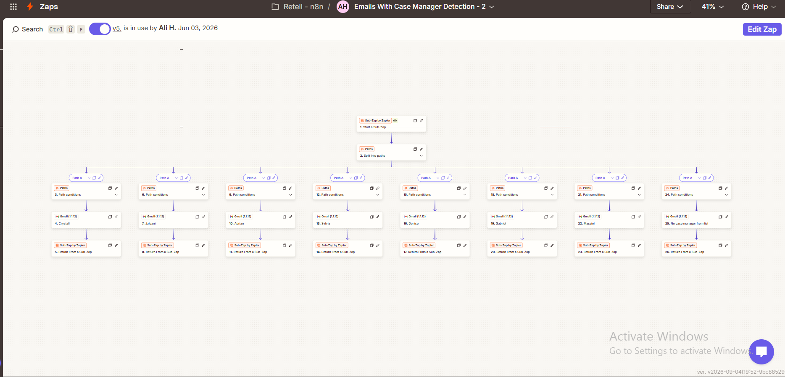

Workflow
The automation:
• Starts from a Sub Zap
• Splits the incoming data into multiple paths
• Checks conditions for the assigned case manager
• Routes each case to the matching email address
• Sends the appropriate email through Gmail
• Returns the result back through the Sub Zap

Case Manager Routing
The workflow includes separate routing paths for:
• Crystal
• Luciani
• Adrian
• Sylvia
• Denise
• Gabriel
• Marcel
• No Case Manager Found

Email Automation
Each path contains its own condition and Gmail action, ensuring case information reaches the correct case manager without manual forwarding.

Technology
• Zapier
• Paths & Conditions
• Gmail
• Sub Zaps
• Email Automation

Result
An automated case manager detection and email routing system that identifies the correct recipient, sends the case information to them, and handles cases where no case manager is assigned.

